Course Play Application

**Problem Statement**

Create a “**Course Play Application**”. Refer below

Create an application using Angular 2 to achieve below mentioned functionalities.

**Software Required**

* Node JS (Latest version)
* Node Packages – Angular CLI
* Notepad ++ or Any IDE

**Concepts**: Components, Directives, Services, Pipes and Routers

1. Create a “**Course Play Application**”. Refer below screen shot:



As seen above there are 2 Hype Links.

1. When the user clicks on “Courses” Hyper link below needs to be displayed.

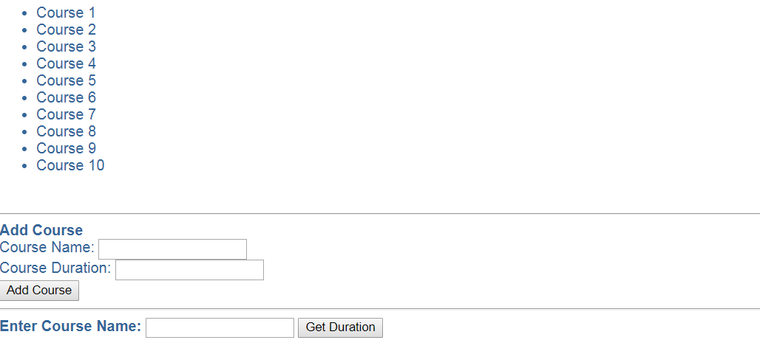

As seen above, “List of Course Names” is being displayed. [This list is being displayed from Course []].

Along with that you would need to provide a section to “Add Course”.

The course should be added to existing list of courses displayed.

Note: While “Adding Course”. Validations are expected.

You could make use of Template-Driven or Reactive Forms.

Refer below screen shot:

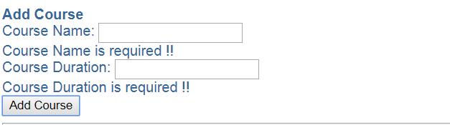

There is another section wherein you would need to enter course name and print the duration.

1. When the user clicks on “Courses with JSON” Hyperlink below needs to be displayed.

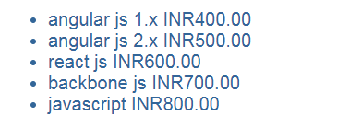

As seen above, List of courses is being displayed. [This list is being displayed from ‘courses.json’]. The ‘courses.json’ has details like courseName, coursePrice and courseId for each course.

Also the course name is displayed in ***lower case*** along with price for each course in ***Indian Rupees.***

Note:

1. In above assignment make use of either Promise / Observable to fetch courses data asynchronously from Array or JSON file.
2. ‘courses.json’ file needs to be created.
3. Make use of services.
4. Make use of Router Module.

**Evaluation Criteria (out of 50):**

This mini project will be done in groups of three to five. Each group will identify a Team Lead who will decide which team member will code for which functionality. This project shall be evaluated at the end of spring module.

**Evaluation Criteria (out of 50):**

|  |  |
| --- | --- |
| Look for all the screens | **10** |
| Client-side validation of inputs | **10** |
| Code Documentation and using coding standards | **03** |
| Overall Business logic. This includes: | **17** |
| Good amount of JSON & Service Use | **10** |